**Chapter 4**

**Entity: Macroeconomics**

**Definition:** Study of the economy as a whole.

**Interpretation:** Macroeconomics examines a region’s economy as a whole, usually at the national level. National governments have an interest in improving the state of their national economy. They do so with macroeconomic policies. Macroeconomic policies have four main aims: real GDP growth, controlled inflation, full employment and balance of payments.

**Formula:**

**Example:**

**Includes:** Real GDP growth, Controlled inflation, Full employment, Balance of payments

**Related_to:** Microeconomics

**Entity: Microeconomics**

**Definition:** Study the economic decisions at the individual, firm, or industry level, and with particular markets, specific goods and services, and product and resource prices.

**Interpretation:** Microeconomics is concerned with how markets and industries function and how prices and output levels in an industry are reached. It is also concerned with output and pricing decisions by individual firms (businesses) that operate within an industry or market.

**Formula:**

**Example:**

**Includes:** Market, Industry

**Related_to:** Macroeconomics

**Entity:** **Real GDP growth**

**Definition:** This provides the means for individuals in the economy to work and earn money to improve their quality of life.

**Interpretation:** Macroeconomic policies attempt to sustain a long-term economic growth trend.

**Formula:**

**Example:** With real GDP growth, businesses may produce and sell more output to earn bigger profits; individuals may have higher wages; government may have higher income from taxes.

**Belongs_to:** Macroeconomics

**Includes:** Gross domestic product (GDP), **Aggregate demand (AD), Economic cycle, Excessive economic growth, Fiscal policy, Monetary policy, Supply-side policy, Multiplier effect**

**Related_to:** Controlled inflation, Full employment, Balance of payments

**Entity: Controlled inflation**

**Definition:** Government use appropriate method to tame inflation.

**Interpretation:**

**Formula:**

**Example:** The Federal Reserve has a target annual inflation rate of 2%, and it uses monetary policy to keep inflation in check and stabilize the economy when inflation rises above that benchmark.

**Belongs_to:** Macroeconomics

**Includes:** **Inflation, Deflation, Stagflation**

**Related_to:** Real GDP growth, Full employment, Balance of payments

**Entity: Full employment**

**Definition:** All individuals willing and able to work have a job. Typically means that there is no cyclical unemployment within the economy.

**Interpretation:** Full employment is not zero unemployment. Full employment occurs when an economy only has frictional and structural unemployment (no cyclical unemployment). In a state of full employment, there will still be some percentage of the workforce that is unemployed, as it takes time to resolve frictional (searching for a job) and structural (upskilling; relocation) issues.

**Formula:**

**Example:**

**Belongs_to:** Macroeconomics

**Includes:** Causes of Unemployment

**Related_to:** Real GDP growth, Controlled inflation, Balance of payments

**Entity: Balance of payments**

**Definition:** The sum of all financial transactions between a country’s residents and residents of foreign nations.

**Interpretation:** When a country exports goods, foreign buyers pay for the output that the country has produced. Similarly, services sold to foreign customers are also exports. Exports are an addition to the level of economic activity in the country. On the other hand, imports represent the purchase of goods made by producers in different countries and services from foreign providers. Spending on imports is, therefore, residents’ spending on items that were not produced in that country. When imports are not equal to exports, balance of payments disequilibrium arises.

**Formula:**

**Example:**

**Belongs_to:** Macroeconomics

**Includes:** Export, Import, Trade surplus, Trade deficit, **Globalisation**

**Related_to:** Real GDP growth, Controlled inflation, Full employment

**Entity: Gross domestic product (GDP)**

**Definition:** The value of the economy’s total output at a given price level for a period.

**Interpretation: Gross domestic product (GDP) and aggregate demand (**AD)are often used interchangeably and are equal in the long run.

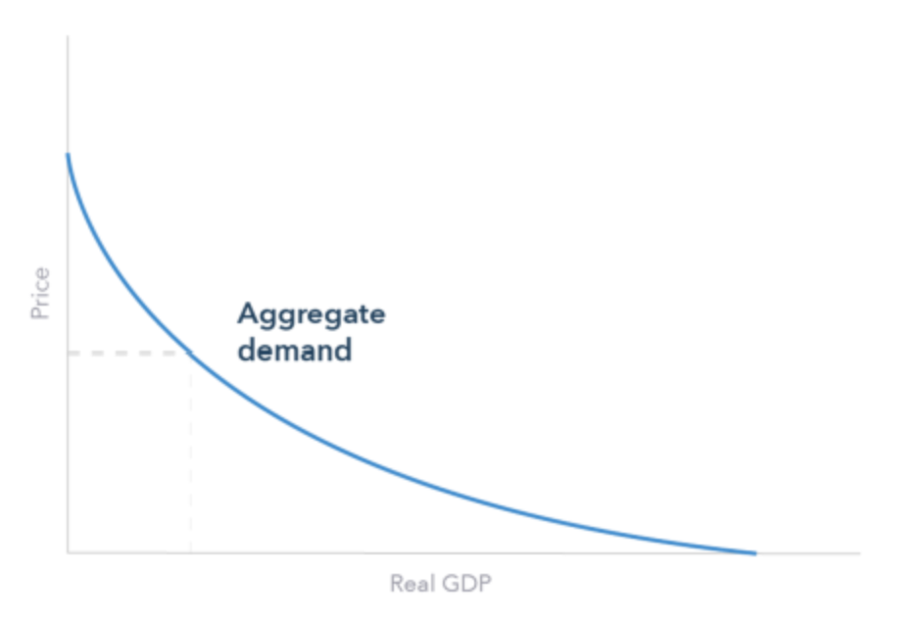

**Formula:** **Gross domestic product (GDP)=** Consumption (C)+ Investment (I)+ Government spending (G)+ Exports (X) – Imports (M)

Consumption (C) refers to local population’s expenditure on goods and services, such as retail spending and rent. Investment (I) refers to commercial expenditure on assets, such as premises and machinery. Government spending (G) refers to government expenditure, such as public service provision and direct investment. Exports (X) – Imports (M) refers to the net impact of exports and imports, such as trade goods and cross-border services.

**Example:**

**Belongs_to:** Real GDP growth

**Related_to:** **Aggregate demand (AD),** Gross National Product (GNP)

**Entity: Aggregate demand (AD)**

**Definition:** The total expenditure in the economy for a period. It is essentially the total demand in the economy.

**Interpretation:** **Gross domestic product (GDP) and aggregate demand (**AD) are often used interchangeably and are equal in the long run.



**Formula:**

**Example:**

**Belongs_to:** Real GDP growth

**Related_to:** **Gross domestic product (GDP),** Aggregate supply (AS)

**Entity: Gross National Product (GNP)**

**Definition:** Gross National Product (GNP) measures the output of a country's residents regardless of the location of the actual underlying economic activity.

**Interpretation:** Income from overseas investments by a country's residents counts in Gross National Product (GNP), and foreign investment within a country's borders does not. This is in contrast to **Gross domestic product (GDP)** which measures economic output and income based on location rather than nationality.

**Formula:** **Gross domestic product (GDP)+ Income remitted from other countries- Income remitted to other countries**= **Gross national product (GNP)**

**Example:** The Philippines had a GNP of US$389.3 and a GDP of US$361.8B in 2020. This may be due to a high level of remittances home from citizens working overseas.

**Related_to:** **Gross domestic product (GDP)**

**Entity: Aggregate supply (AS)**

**Definition:** The real value of the total output an economy can produce in a period.

**Interpretation:** The determinants of aggregate supply are: input prices, productivity and legal-institutional environment. Input prices refer to prices of inputs to produce goods, such as materials and assets. Productivity refers to the possible level of production from available input, which is affected by methods of working, technological advancement and available resources. Legal-institutional environment refers to the state of legal and regulatory factors that impact supply, such as taxes, subsidies and regulations.

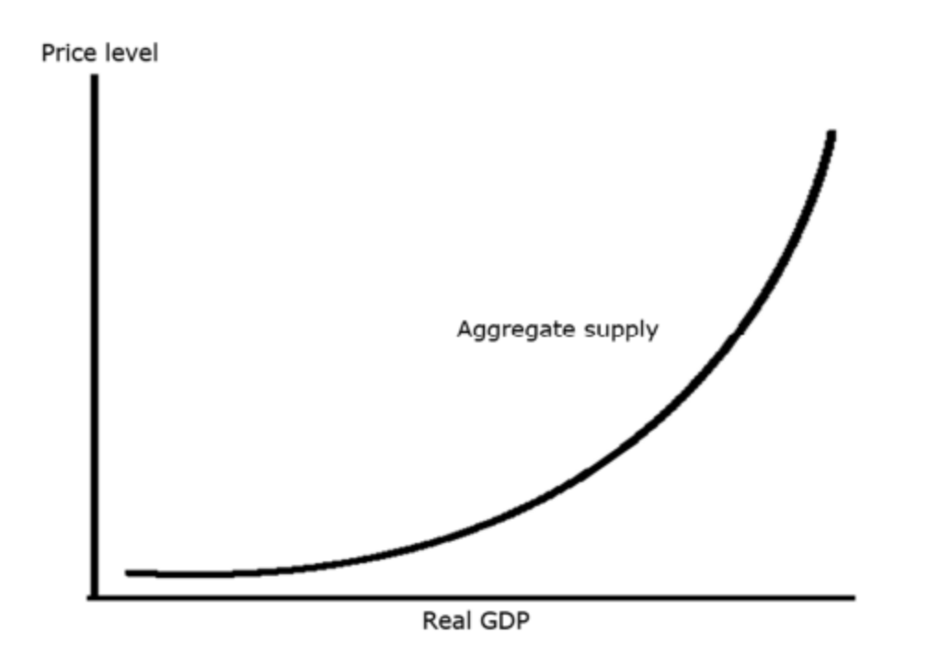

**Formula:**

**Example:** Bargy Co has to limit production because it cannot afford the increasing wages of its staff illustrates input prices. Remo Co has successfully implemented an automated production line, increasing production substantially illustrates productivity. WERT Co has received a government grant, enabling it to open another factory illustrates legal-institutional environment.

**Related_to:** **Aggregate demand (AD)**

**Entity: Economic cycle**

**Definition:** The fluctuations in economic activity over time, characterised by states of expansion and contraction. The economic cycle is typically measured in terms of GDP growth.

**Interpretation:** **Economic cycle usually includes four phases: expansion, peak, contraction and trough. Expansion refers to the level of economic activity in a period is higher than the level in a corresponding previous period. Peak refers to the level of economic activity is at its maximum. Contraction refers to the level of economic activity in a period is lower than the level in a corresponding previous period. Trough refers to the level of economic activity is at a minimum.**

**Formula:**

**Example:**

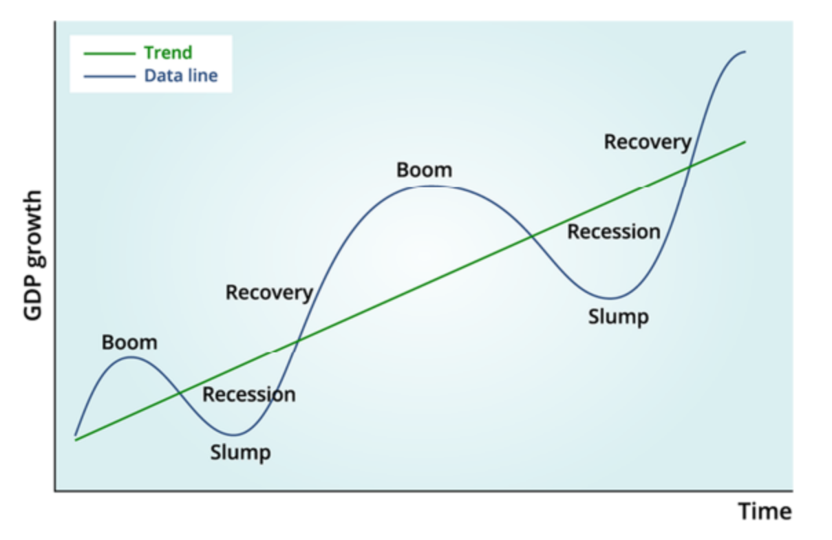

A summary of the impact of each state of the economic cycle is shown below.

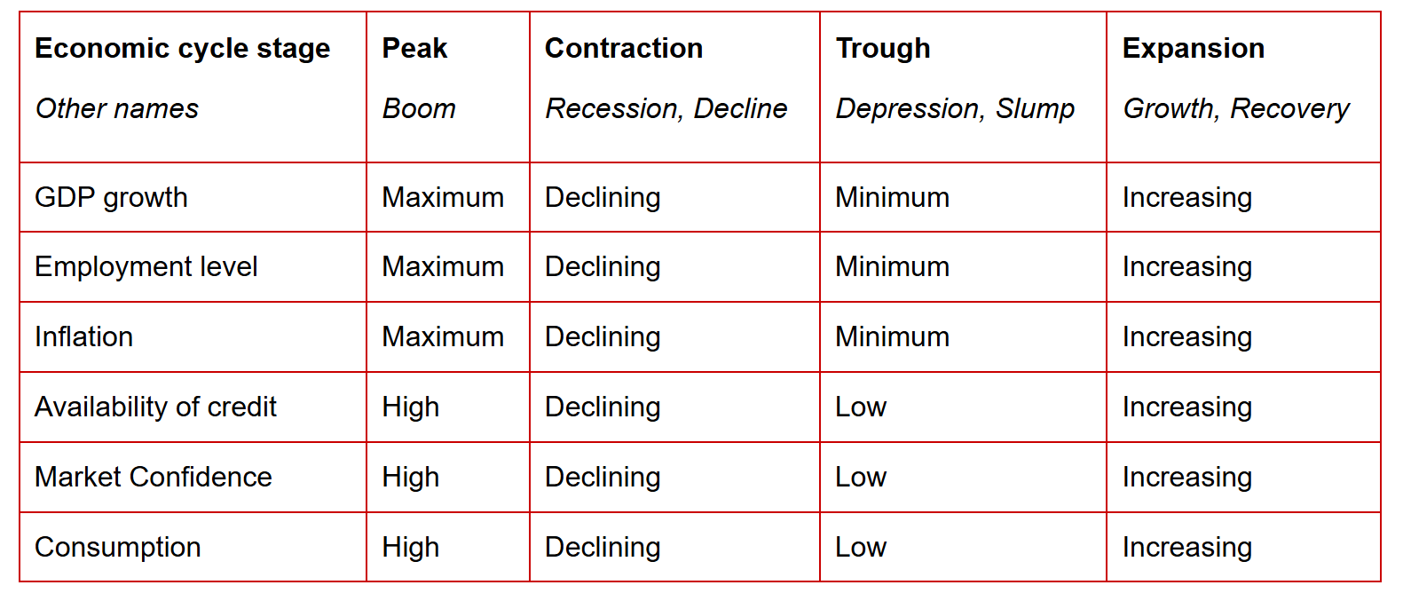

**Belongs_to:** Real GDP growth

**Entity: Excessive economic growth**

**Definition:** Certain situations where focusing on economic growth leads to more adverse than positive effects.

**Interpretation:**

**Formula:**

**Example:** Excessive use of credit, and over-use of economic resources, will lead to short-term economic growth but may lead to the economy overheating, suffering from high inflation, eventually reducing economic activity and leading to a recession.

**Belongs_to:** Real GDP growth

**Entity: Real GDP**

**Definition:** GDP without inflation effect.

**Interpretation:**

**Formula:** Real GDP= Nominal GDP / (1+ inflation rate)

**Example:** In 20X2, Ayeland’s real GDP is measured at $5 billion. The inflation rate for 20X2 was 10%. Calculate Ayeland’s nominal GDP.

Nominal GDP= $5 billion * (1+10%)= $5.5 billion

**Belongs_to: Gross domestic product (GDP)**

**Related_to:** Nominal GDP

**Entity: Nominal GDP**

**Definition:** GDP with inflation effect.

**Interpretation:**

**Formula:** Nominal GDP= Real GDP * (1+ inflation rate)

**Example:** In 20X2, Ayeland’s nominal GDP is measured at $5.5 billion. The inflation rate for 20X2 was 10%. Calculate Ayeland’s real GDP.

$5.5 billion= Real GDP * (1+10%), so real GDP is $5 billion

**Belongs_to: Gross domestic product (GDP)**

**Related_to:** Real GDP

**Entity: Inflation**

**Definition:** An increase in prices for goods and services over time.

**Interpretation:**

**Formula:**

**Example:** Imagine you have $120 and you can buy 12 books with that money today, each costing $10. One year later, due to inflation, the price of each book increases to $12. Now, with the same $120, you can only buy 10 books instead of 12.

**Belongs_to:** Controlled inflation

**Includes:** Causes of inflation, consequences of inflation

**Related_to:** Deflation, Stagflation

**Entity: Deflation**

**Definition:** A decrease in prices for goods and services over time.

**Interpretation:**

**Formula:**

**Example:** Imagine you have $120 and you can buy 10 books with that money today, each costing $12. One year later, due to deflation, the price of each book increases to $10. Now, with the same $120, you can only buy 12 books instead of 10.

**Belongs_to:** Controlled inflation

**Includes:** Consequences of deflation

**Related_to:** Inflation, Stagflation

**Entity: Stagflation**

**Definition:** An economic condition characterized by stagnant economic growth, high unemployment, and high inflation.

**Interpretation:**

**Formula:**

**Example:** In 2008, a loaf of bread in Zimbabwe might have cost Z$10 million in the morning and Z$100 million by the afternoon. Despite such high prices, there was little economic activity, and businesses struggled to operate, leading to widespread unemployment. This extreme case of stagflation in Zimbabwe was exacerbated by both internal policy decisions and external economic pressures, leading to one of the worst economic crises in modern history.

**Belongs_to:** Controlled inflation

**Related_to:** Inflation, Deflation

**Entity: Causes of inflation**

**Definition:** The reasons for inflation.

**Interpretation:** There are two main types of inflation: Demand-pull and cost-push.

**Formula:**

**Example:**

**Belongs_to:** Inflation

**Includes:** Demand-pull, Cost push

**Entity: Demand-pull**

**Definition:** Expenditure on goods and services (aggregate or total demand) may increase faster than the economy can increase output. Thus, supply can’t keep pace with demand which causes prices to rise.

**Interpretation:** Consumption trends cause short-term demand-pull inflation (a significant increase in demand for an exotic fruit causes prices to rise as consumers are willing to pay more for the fruit). In the long term, this type of inflation will decline as additional supplies are created or interest in the good (demand) falls.

**Formula:**

**Example:** People start to buy items now because they expect them to increase in price illustrates demand-pull inflation. People borrow more to spend more also illustrates demand-pull inflation.

**Belongs_to:** Causes of inflation

**Related_to:** Cost push

**Entity: Cost push**

**Definition:** Increasing input costs force producers to raise prices to cover costs and maintain profit margins.

**Interpretation:** Cost push may include wages, local resources, cost of imported inputs.

**Formula:**

**Example:** Workers win a significant increase in their rate of pay illustrates cost push inflation. The foreign exchange value of the country’s currency falls, making imports more expensive to buy also illustrates cost push inflation.

**Belongs_to:** Causes of inflation

**Related_to:** Demand-pull

**Entity: Consequences of inflation**

**Definition:** The results for inflation.

**Interpretation:** There are three main consequences of inflation: loss of purchasing Power, redistribution of wealth and foreign transaction

**Formula:**

**Example:**

**Belongs_to:** Inflation

**Includes:** Loss of purchasing power, redistribution of wealth, Foreign transaction

**Related_to:** Consequences of deflation

**Entity: Loss of purchasing power**

**Definition:** Money loses its value and buys fewer goods and services than previously.

**Interpretation:** This leads to a loss of purchasing power for consumers on fixed incomes (pensioner, bondholder) which cannot rise with inflation.

**Formula:**

**Example:** Imagine you have $100 and you regularly buy a grocery basket containing essential items like milk, bread, eggs, and vegetables for $100. Over the course of a year, the average inflation rate is 5%. You can no longer buy the same basket of groceries with $100; you are $5 short.

**Belongs_to:** Consequences of inflation

**Related_to:** Redistribution of wealth, Foreign transaction

**Entity: Redistribution of wealth**

**Definition:** The wealth of individual is redistributed. Normally, borrower take the advantage of the inflation, while lender suffer in the time of inflation.

**Interpretation:** There is evidence from research that high inflation levels make economic inequalities (the gap between the income of rich and poor) worse. This is especially true if inflation primarily affects essential goods (groceries, fuel), which form a significant part of low-income consumers’ expenditure.

**Formula:**

**Example:** There is a redistribution of wealth from lenders to borrowers, as inflation reduces the real value of receivables.

**Belongs_to:** Consequences of inflation

**Related_to:** Loss of purchasing power, Foreign transaction

**Entity: Foreign transaction**

**Definition:** Transactions with foreign countries may also affected by inflation.

**Interpretation:**

**Formula:**

**Example:** When there is an inflation, the price of goods will go up. In the short term, exchange rate remains unchanged, so export will become more expensive.

**Belongs_to:** Consequences of inflation

**Related_to:** Loss of purchasing power, Redistribution of wealth

**Entity: Consequences of deflation**

**Definition:** The results for deflation

**Interpretation:** There are five main consequences of deflation: price fall, consumer defer purchases, economic activity falls, unemployment rises and demand falls.

**Formula:**

**Example:**

**Belongs_to:** Deflation

**Related_to:** Consequences of inflation

**Entity: Causes of Unemployment**

**Definition:** The reasons for unemployment.

**Interpretation:** There are five main types of unemployment: frictional unemployment, seasonal unemployment, structural unemployment, cyclical unemployment and real-wage unemployment**.**

**Formula:**

**Example:**

**Belongs_to:** Full employment

**Includes:** Frictional unemployment, Seasonal unemployment, Structural unemployment, Cyclical unemployment, Real-wage unemployment

**Entity: Frictional unemployment**

**Definition:** Workers are temporarily unemployed as they are searching for their first job or transitioning between jobs.

**Interpretation:**

**Formula:**

**Example:** Gary has just graduated from university and is seeking employment illustrates frictional unemployment. Holly has resigned from her job and is taking a short break before returning to work also illustrates frictional unemployment.

**Belongs_to:** Causes of Unemployment

**Related_to:** Seasonal unemployment, Structural unemployment, Cyclical unemployment, Real-wage unemployment

**Entity: Seasonal unemployment**

**Definition:** Seasonal changes in demand cause short-term unemployment.

**Interpretation:**

**Formula:**

**Example:** There are fewer jobs available at the beach during the winter months illustrates seasonal unemployment. Toy manufacturing hires fewer workers during the off-peak seasons also illustrates seasonal unemployment.

**Belongs_to:** Causes of Unemployment

**Related_to:** Frictional unemployment, Structural unemployment, Cyclical unemployment, Real-wage unemployment

**Entity: Structural unemployment**

**Definition:** Unemployment caused by the composition of the workforce not meeting the needs of the market due to mismatch in geographical location and occupational skill set.

**Interpretation:**

**Formula:**

**Example:** Flora has been made redundant because her company has automated the process she worked on illustrates structural unemployment. Riley is unemployed as fewer jobs in her region require her skills also illustrates structural unemployment.

**Belongs_to:** Causes of Unemployment

**Related_to:** Frictional unemployment, Seasonal unemployment, Cyclical unemployment, Real-wage unemployment

**Entity: Cyclical unemployment**

**Definition:** Unemployment due to declining demand. Usually, a result of the economic cycle (recession).

**Interpretation:**

**Formula:**

**Example:** Tina has been laid off as her company has closed a factory due to poor sales illustrates cyclical unemployment.

**Belongs_to:** Causes of Unemployment

**Related_to:** Frictional unemployment, Seasonal unemployment, Structural unemployment, Real-wage unemployment

**Entity: Real-wage unemployment**

**Definition:** Unemployment due to high minimum wages causes firms to limit recruitment.

**Interpretation:**

**Formula:**

**Example:** RTW Co has frozen hiring as it has run out of budget to hire workers at the mandatory minimum wage illustrates real-wage unemployment.

**Belongs_to:** Causes of Unemployment

**Related_to:** Frictional unemployment, Seasonal unemployment, Structural unemployment, Cyclical unemployment

**Entity: Export**

**Definition:** A product or service produced in one country and sold to a buyer abroad.

**Interpretation:** Instead of confining themselves within their geographical borders, countries often intentionally seek external markets around the world for commerce, achieving greater revenue and transactional opportunities.

**Formula:**

**Example:** The United States is one of the top exporters of automotive vehicles. As domestic companies manufacture cars, trucks, and other vehicles, these are shipped around the world and used by non-U.S. entities.

**Belongs_to:** Balance of payments

**Related_to:** Import, Trade surplus, Trade deficit

**Entity: Import**

**Definition:** A product or service produced abroad and purchased in your home country.

**Interpretation:** Countries are most likely to import goods or services that their domestic industries cannot produce as efficiently or cheaply as the exporting country. Countries may also import raw materials or commodities that are not available within their borders.

**Formula:**

**Example:** Many countries import oil because they cannot produce it domestically or cannot produce enough to meet demand.

**Belongs_to:** Balance of payments

**Related_to:** Export, Trade surplus, Trade deficit

**Entity: Trade surplus**

**Definition:** An economic measure of a positive balance of trade, where a country's exports exceed its imports.

**Interpretation:** When focusing solely on trade effects, a trade surplus means there is high demand for a country’s goods in the global market, which pushes the price of those goods higher and leads to a direct strengthening of the domestic currency.

**Formula:**

**Example:** In recent times, the economy of China has become more developed, and it is now the dominant exporter of goods in the global economy. Per data released for July 2022, China’s trade surplus has expanded to approximately $101 billion, which surpassed earlier estimates set by economists

**Belongs_to:** Balance of payments

**Includes:** Import, Export, Trade deficit

**Entity: Trade deficit**

**Definition:** An economic measure of a negative balance of trade, where a country's imports exceed its exports.

**Interpretation:** A trade deficit or net amount can be calculated on different categories within an international transaction account. These include goods, services, goods and services, current account, and the sum of balances on the current and capital accounts. The sum of the balances on the current and capital accounts equals net lending/ borrowing.

**Formula:**

**Example:** In 2023, the U.S. trade deficit dropped to $773.4 billion from $951.2 billion in 2022. This was due to more exports and fewer imports.

**Belongs_to:** Balance of payments

**Related_to:** Import, Export, Trade surplus

**Entity: Globalisation**

**Definition:** The promotion of the free flow of trade between countries without restrictions.

**Interpretation:** Various measures have been put in place to promote free trade internationally, facilitated by the World Trade Organisation.

**Formula:**

**Example:** The North American Free Trade Agreement (NAFTA) has eliminated tariffs on goods traded between the United States, Canada, and Mexico, increasing trade.

**Belongs_to:** Balance of payments

**Entity: Fiscal policy**

**Definition:** Government spending and taxation influence economic activity.

**Interpretation:** Fiscal policy includes government borrowings, government spending and taxation.

**Formula:**

**Example:** The Inflation Reduction Act of 2022 was a $737 billion law with large investments in renewable energy and electric vehicles, which were considered strong areas of future growth.

**Belongs_to:** Real GDP growth

**Includes:** Positive Public Sector Net Cash Requirement (Positive PSNCR), Negative Public Sector Net Cash Requirement (Negative PSNCR), Direct tax, Indirect tax, Progressive tax, Regressive tax

**Related_to:** **Monetary policy, Supply-side policy**

**Entity: Monetary policy**

**Definition:** Control of the available money supply of a country.

**Interpretation:** **Monetary policy includes interest rates, exchange rates and reserve requirements.**

**Formula:**

**Example:** During double-digit inflation in the 1980s, the Federal Reserve raised its benchmark interest rate to 20%. Though the effect of high rates spurred a recession, inflation was reduced to a range of 3% to 4% over the following years.

**Belongs_to:** Real GDP growth

**Includes:** Interest rate, Exchange rate, Open market operation

**Related_to:** **Fiscal policy, Supply-side policy**

**Entity: Supply-side policy**

**Definition:** How government taxes and other regulations support the supply of goods and services.

**Interpretation:** **Supply-side policy includes tax breaks for critical industries, grants and aid for the development of industries and de-regulation.**

**Formula:**

**Example:** Malaysia engages in privatization policies to improve the productivity of the country for a long period of time. As an example, Cement Industries of Malaysia, Sports Toto Malaysia, and Malaysian International Shipping Corporation, Tenaga Nasional Berhad, Malaysian Airline System are more tend to be aligned with the privatization policies.

**Belongs_to:** Real GDP growth

**Includes:** **Reducing direct taxation,** Improve workforce skills, Reduce the power of trade unions, Encourage **research and development**

**Related_to:** **Fiscal policy, Monetary policy**

**Entity: Multiplier effect**

**Definition:** Proportional amount of increase, in final income that results from an injection of capital.

**Interpretation:** The net impact of government spending on GDP is usually higher than the amount spent ($1 billion of government spending will typically increase GDP by more than $1 billion of GDP).

**Formula:**

**Example:** Assume government makes a $20m capital investment to build a new airport. After five years, the new facilities operating at maximum capacity, the airport generates income increases by $40m. This means that the multiplier effect was 2 ($40m / $20m). Simply put, every $1 of investment produced an extra $2 of income.

**Belongs_to:** Real GDP growth

**Entity: Positive Public Sector Net Cash Requirement (Positive PSNCR)**

**Definition:** When the government spends more in a year than it raises in taxation revenues, the excess amount of spending over tax revenues.

**Interpretation:**

**Formula:**

**Example:** The amount of UK government needs to borrow in a year to meet its shortfall of spending and tax receipts (in 2008-09 government has a PSNCR of about £115bn).

**Belongs_to:** Fiscal policy

**Related_to:** Negative Public Sector Net Cash Requirement (Negative PSNCR)

**Entity: Negative Public Sector Net Cash Requirement (Negative PSNCR)**

**Definition:** When the government spends less in a year than it raises in taxation revenues, the excess amount of spending over tax revenues.

**Interpretation:**

**Formula:**

**Example:** Negative PSNCR has only happened 12 time in the UK since 1945.

**Belongs_to:** Fiscal policy

**Related_to:** Positive Public Sector Net Cash Requirement (Positive PSNCR)

**Entity: Direct tax**

**Definition:** Taxes paid directly to the government. Includes corporate and income taxes.

**Interpretation:** Direct taxes are the person immediately paying the tax is the person that the government is seeking to tax.

**Formula:**

**Example:** Income tax, real property tax, personal property tax, and taxes on assets, all of which are paid by an individual taxpayer directly to the government.

**Belongs_to:** Fiscal policy

**Related_to:** Indirect tax, Progressive tax, Regressive tax

**Entity: Indirect tax**

**Definition:** Taxes collected on behalf of the government through agents. Includes value-added tax (VAT).

**Interpretation:** Indirect taxes are taxation on an individual or entity, which is ultimately paid for by another person. The body that collects the tax will then remit it to the government.

**Formula:**

**Example:** Excise duties on fuel, liquor, and cigarettes are all considered examples of indirect taxes.

**Belongs_to:** Fiscal policy

**Related_to:** Direct tax, Progressive tax, Regressive tax

**Entity: Progressive tax**

**Definition:** High net-worth individuals pay a higher proportion of their income as tax than low net-worth individuals.

**Interpretation:**

**Formula:**

**Example:** The income tax rate for most countries is usually progressive (higher income is taxed at a higher rate) illustrates progressive tax. Capital gains tax (tax on gains from investments) affects high net-worth individuals more, as they own more assets also illustrates progressive tax.

**Belongs_to:** Fiscal policy

**Related_to:** Direct tax, Indirect tax, Regressive tax

**Entity: Regressive tax**

**Definition:** High net-worth individuals pay a lower proportion of their income as tax than low net-worth individuals.

**Interpretation:**

**Formula:**

**Example:** Some studies have found that value-added tax may have regressive effects, especially if essential goods (groceries, fuel, etc.) are not exempted.

**Belongs_to:** Fiscal policy

**Related_to:** Direct tax, Indirect tax, Progressive tax

**Entity: Interest rate**

**Definition:** The amount charged on top of the principal by a lender to a borrower for the use of assets.

**Interpretation:** An interest rate also applies to the amount earned at a bank or credit union from a deposit account. A borrower that is considered low-risk by the lender will have a lower interest rate. A loan that is considered high-risk will have a higher interest rate.

**Formula:**

**Example:** Higher interest rates will make borrowing more expensive (hence less attractive) and reduce loan demand. Demand for goods and services will fall, lowering inflation as suppliers reduce prices to sell surplus inventories. Lower interest rates will make borrowing cheaper and increase demand, but the inflation rate may rise.

**Belongs_to: Monetary policy**

**Related_to:** Exchange rate, Open market operation

**Entity: Exchange rate**

**Definition:** The rate at which one currency can be exchanged for another currency.

**Interpretation:** Changes in exchange rates affect businesses by increasing or decreasing the cost of supplies and finished products that are purchased from another country. It changes, for better or worse, the demand abroad for their exports and the domestic demand for imports. Significant changes in a currency rate can encourage or discourage foreign tourism and investment in a country.

**Formula:**

**Example:** Strengthening the exchange rate means the local currency is worth more foreign currency than before. If the current exchange rate of US$: Euro is 1:1, and this shifts to 1:1.1, it means the US$ has strengthened relative to the Euro. 1 US$ buys more Euro than previously. Weakening the exchange rate means the local currency is worth less foreign currency than previously. In the above example, the Euro has weakened relative to the US$. 1 Euro buys less US$ than previously.

**Belongs_to: Monetary policy**

**Related_to:** Interest rate, Open market operation

**Entity: Open market operation**

**Definition:** Purchase and sale of securities in the open market by the central bank.

**Interpretation:** Buying securities adds money to the system, lowers rates, makes loans easier to obtain, and increases economic activity. Selling securities removes money from the system, raises rates, makes loans more expensive, and decreases economic activity.

**Formula:**

**Example:** The central bank may buy £10 million worth of treasury bonds from commercial banks in the open market. In return, the central bank pays the commercial banks with newly created reserves. As a result, the commercial banks now have more reserves available to lend to businesses and consumers. This increase in lending capacity stimulates borrowing, spending, and investment in the economy, thus boosting economic activity.

**Belongs_to: Monetary policy**

**Related_to:** Interest rate, Exchange rate

**Entity: Reducing direct taxation**

**Definition:** Reducing the direct tax burden such as income tax and corporation tax.

**Interpretation:** Reducing direct taxes will increase the incentive to earn more and make more profits. They say it is better to have high indirect taxes – such as sales tax – than high direct taxes.

**Formula:**

**Example:** Corporation tax rate reduced from 20% to 19% due to Covid-19.

**Belongs_to: Supply-side policy**

**Related_to:** Improve workforce skills, Reduce the power of trade unions, Encourage **research and development**

**Entity: Improve workforce skills**

**Definition:** Identify current work skill gap and create plan to fulfill the gap.

**Interpretation:** Output in the economy will improve if workers are better trained and have better skills, increasing their capabilities. The government may train people who are unemployed and so equip them for work and subsidise companies to train their employees. Skills may also need to be updated as technology changes, so workers may need to be retrained if their abilities become outdated.

**Formula:**

**Example:** Financial accountant improves the ability of spreadsheet skill.

**Belongs_to: Supply-side policy**

**Related_to:** **Reducing direct taxation**, Reduce the power of trade unions, Encourage **research and development**

**Entity: Reduce the power of trade unions**

**Definition:** The impact of trade unions have been greatly reduced.

**Interpretation:** The government may change employment laws to reduce trade unions’ bargaining powers, such as restricting when strikes occur so that firms can employ workers more cheaply.

**Formula:**

**Example:** Trade unions have the ability to go on strike to campaign for higher wages and can also put pressure on a firm to avoid redundancies. Reducing the power of trade unions will give the firm greater flexibility to hire and fire workers and set market clearing wages.

**Belongs_to: Supply-side policy**

**Related_to:** **Reducing direct taxation,** Improve workforce skills, Encourage **research and development**

**Entity: Encourage research and development**

**Definition:** Government encourage activities companies undertake to innovate and introduce new products and services or to improve their existing offerings.

**Interpretation:** The government can encourage investment in research and development activity to promote innovation and improve productivity.

**Formula:**

**Example:** China has rolled out a series of steps to encourage foreign investment in research and development, a move widely applauded by international business leaders who have pledged to bolster their presence in the Chinese market. A policy document released by the Ministry of Commerce and the Ministry of Science and Technology on Jan 18 outlined 16 policy measures to strengthen support for foreign-funded R&D centers.

**Belongs_to: Supply-side policy**

**Related_to: Reducing direct taxation,** Improve workforce skills, Reduce the power of trade unions

**Chapter 5**

**Entity: Market**

**Definition:** Where goods and services are sold.

**Interpretation:** Markets vary widely for several reasons, including the kinds of products sold, location, duration, and size. The constituency of the customer base, size, legality, and other factors are equally influential. Aside from the two most common markets—physical and virtual—there are other kinds of markets where parties can gather to execute their transactions.

**Formula:**

**Example:** Markets may be represented by physical locations where transactions are made. These include retail stores and similar businesses that sell individual items to wholesale markets selling goods to distributors. Market can also be virtual. Internet-based stores and auction sites such as Amazon and eBay are examples of markets where transactions can occur entirely online, and the parties involved never physically connect.

**Belongs_to:** Microeconomics

**Includes:** Demand, Supply**, Equilibrium price, Equilibrium quantity, Perfect competition, Imperfect competition, Monopoly, Oligopoly, Monopolistic competition**

**Related_to:** Industry

**Entity: Industry**

**Definition:** The combination of firms that produce a good or service.

**Interpretation:** Investors often compare companies within the same industry for investment opportunities. Stocks of companies in the same industry will usually trade in the same direction, as their fundamentals can be affected by market factors in the same way.

**Formula:**

**Example:** Examples of industries include banks, asset management companies, insurance companies, and brokerages. Companies that fall into the same industry offer similar products or services and compete for customers who require them. For instance, banks will compete with one another for customers who require checking and savings accounts. Asset management firms compete for investment clients.

**Belongs_to:** Microeconomics

**Related_to:** Market

**Entity: Demand**

**Definition:** The quantity of goods and services consumers want to purchase, at various price levels, for a specified period.

**Interpretation:** Demand has an inverse relationship with price. If prices rise, demand falls. If prices fall, demand rises. Price is the determinant of demand.

**Formula:**

**Example:** If the price of Product A is $5, the quantity demanded by the market is 40. If the price of Product A is $6, the quantity demanded by the market is 37. Note that demand falls as the price rises.

**Belongs_to:** Market

**Includes:** Demand curve, Substitute, Complement, Inferior goods, Normal goods, Luxury goods, Elastic, Inelastic, Price elasticity of demand (PED), Income elasticity of demand, Cross elasticity of demand (XED)

**Related_to:** Supply

**Entity: Demand curve**

**Definition:** A line on a graph with axes of quantity and price showing demand.

**Interpretation:**

**Formula:**

**Example:**

The demand at various price levels can be shown on a graph:

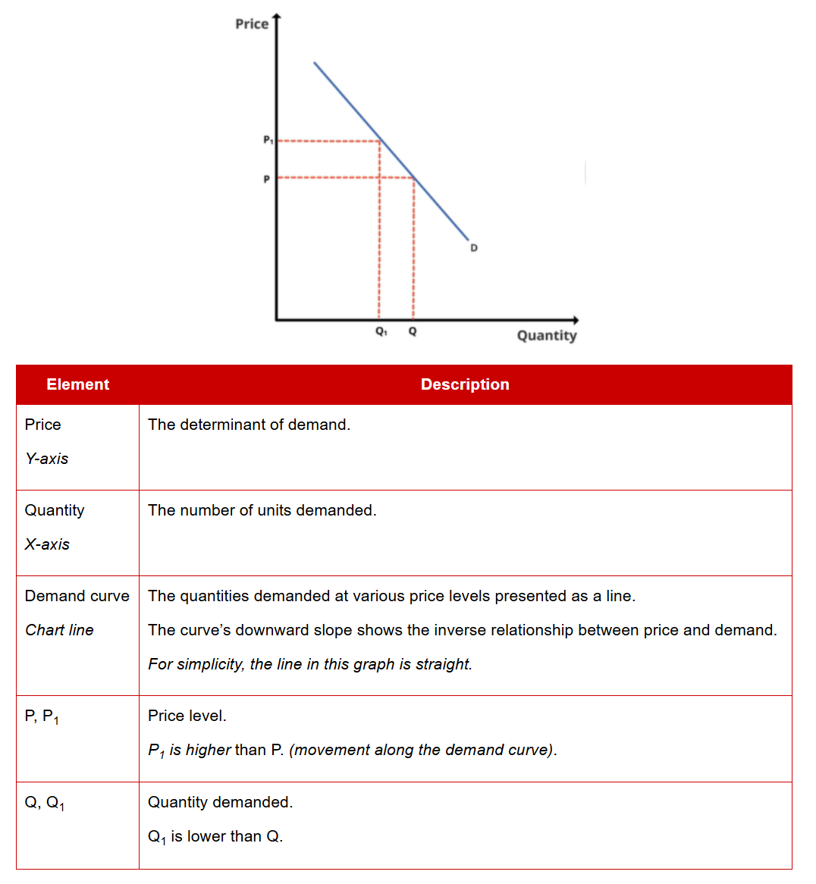

**Belongs_to:** Demand

**Includes:** Movement along demand curve, Shift in demand curve

**Related_to:** Supply curve

**Entity: Movement along demand curve**

**Definition:** The amount of quantity demanded by the consumer changes with the rise and fall in the price of the commodity if other determinants of demand remain constant.

**Interpretation:** Higher prices lead to lower demand (contraction). Lower prices lead to higher demand (expansion). This is shown as movement along the demand curve.

**Formula:**

**Example:**

The demand at various price levels can be shown on a graph:

When price is P, quantity is Q, when price is P1, quantity is Q1. This shows a movement along the demand curve.



**Belongs_to:** Demand curve

**Related_to:** Shift in demand curve

**Entity: Shift in demand curve**

**Definition:** The determinants of demand shift the entire demand curve left or right, meaning that demand changes despite prices remaining unchanged.

**Interpretation:** When the amount of commodity demanded changed due to non-price factors, there is no extension or contraction in the curve but the formation of the entirely new demand curve. As a result, demand curve shifts from its original position.

**Formula:**

**Example:** If demand for a good at $10 has changed from 10,000 units to 12,000 units, the demand curve has shifted right. If demand for a good at $10 has changed from 10,000 units to 8,000 units, the demand curve has shifted left. In addition to this, the demand for cold drinks in the market may increase substantially even at same price due to hot weather.

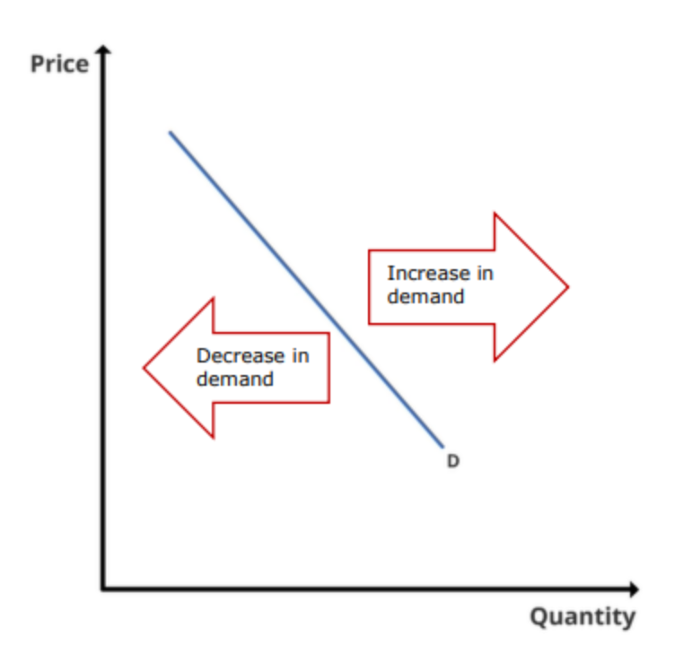

**Belongs_to:** Demand curve

**Includes:** Consumer tastes, Number of buyers, Income levels, Price of related goods, Consumer expectations

**Related_to:** Movement along demand curve

**Entity: Consumer tastes**

**Definition:** Preferences of consumers on the desirability of a product (trends and fads).

**Interpretation:** Marketing can influence the perception of consumers.

**Formula:**

**Example:** RKS Co has had a successful online marketing campaign that significantly increased demand for its cakes illustrates consumer tastes. Judy’s friends have influenced her to buy more organic food also illustrates consumer tastes.

**Belongs_to:** Shift in demand curve

**Related_to:** Number of buyers, Income levels, Price of related goods, Consumer expectations

**Entity: Number of buyers**

**Definition:** Changes in the number of buyers in the market influence demand.

**Interpretation:** Normally, more buyers increase demand, fewer buyers decrease demand.

**Formula:**

**Example:** There is less demand for businesses in Village X because its population has been decreasing illustrates number of buyers. Significant immigration from Country A to B has increased demand for Country A’s products in Country B also illustrates number of buyers.

**Belongs_to:** Shift in demand curve

**Related_to:** Consumer tastes, Income levels, Price of related goods, Consumer expectations

**Entity: Income levels**

**Definition:** Changes in the level of income affect demand.

**Interpretation:** Different goods types have varying sensitivity to income levels. Normal goods experience higher demand with higher income levels. Inferior goods experience lower demand with higher income levels.

**Formula:**

**Example:** As income levels of country A increase, sales of the lowest grade of white rice has declined as consumer opt for higher-quality imported varieties illustrates income levels. Higher income levels have led to significant increases in spending on tuition and enrichment activities for children also illustrates income levels.

**Belongs_to:** Shift in demand curve

**Related_to:** Consumer tastes, Number of buyers, Price of related goods, Consumer expectations

**Entity: Price of related goods**

**Definition:** The selling price of complements and substitutes.

**Interpretation:** The prices of related goods impact the demand curve. A substitute is a good that can replace another good in satisfying needs. If prices of substitutes decrease, demand for the good decreases as consumers choose the cheaper alternative. A complement is a good consumed together with another good. If prices of complements decrease, demand for the good increases as they obtain better value from consuming the goods together.

**Formula:**

**Example:** When cars are cheaper to buy and own, consumers drive more and use less public transport and taxi services illustrates price of related goods. When petrol is cheaper, consumers drive more, as the cost of travelling via motor vehicle is lower also illustrates price of related goods.

**Belongs_to:** Shift in demand curve

**Related_to:** Consumer tastes, Number of buyers, Income levels, Consumer expectations

**Entity: Consumer expectations**

**Definition:** Any set of behaviors or actions that individuals anticipate when interacting with a company.

**Interpretation:** Consumers’ expectations of price and income in the future affect current demand. Higher expected prices increase current demand. Higher expected income increases current demand.

**Formula:**

**Example:** Fearing a shortage of coffee beans due to bad weather in source countries may lead to higher prices; consumers buy more coffee beans now illustrates consumer expectations. Joey buys a new watch in anticipation of the bonus he’s expecting to receive also illustrates consumer expectations.

**Belongs_to:** Shift in demand curve

**Related_to:** Consumer tastes, Number of buyers, Income levels, Price of related goods

**Entity: Substitutes**

**Definition:** A good that can replace another good in satisfying needs.

**Interpretation:** If prices of substitutes decrease, demand for the good decreases as consumers choose the cheaper alternative.

**Formula:**

**Example:** Soya milk is used as a substitute for dairy milk.

**Belongs_to:** Demand

**Related_to:** Complements

**Entity: Complements**

**Definition:** A good consumed together with another good.

**Interpretation:** If prices of complements decrease, demand for the good increases as they obtain better value from consuming the goods together.

**Formula:**

**Example:** Goods like peanut butter and toast are complements.

**Belongs_to:** Demand

**Related_to:** Substitutes

**Entity: Inferior goods**

**Definition:** One whose demand drops when people's incomes rise.

**Interpretation:** Inferior goods are the opposite of normal goods, whose demand increases when incomes increase.

**Formula:**

**Example:** As opposed to eating a steak for dinner, an individual may opt for an inferior product such as canned meat or frozen food.

**Belongs_to:** Demand

**Related_to:** Normal goods, Luxury goods

**Entity: Normal goods**

**Definition:** A good that experiences an increase in demand due to an increase in a consumer's income.

**Interpretation:** Demand for normal goods is determined by patterns of consumer behavior and as income levels rise, consumers can often afford goods that were not previously available to them.

**Formula:**

**Example:** Food, clothing, entertainment, transportation, electronics, home Appliances.

**Belongs_to:** Demand

**Related_to:** Inferior goods, Luxury goods

**Entity: Luxury goods**

**Definition:** Goods not necessary to live, but it is deemed highly desirable within a culture or society.

**Interpretation:** Demand for luxury goods increases when a person's wealth or income increases. Typically, the greater the percentage increase in income, the greater the percentage increase in luxury item purchases.

**Formula:**

**Example:** Jewelry and high-end watches, high-end automobile, yacht.

**Belongs_to:** Demand

**Related_to:** Inferior goods, Normal goods

**Entity: Supply**

**Definition:** The quantity of goods and services producers are willing to supply, at various price levels, for a specified period.

**Interpretation:** Supply has a positive relationship with price. If prices rise, supply rises. If prices fall, supply falls. Price is the determinant of supply.

**Formula:**

**Example:**

**Belongs_to:** Market

**Includes:** Supply curve, Average cost (AC), Marginal cost (MC), Law of diminishing returns, Marginal revenue (MR), Profit maximising rule

**Related_to:** Demand

**Entity: Supply curve**

**Definition:** A line on a graph with axes of quantity and price showing supply.

**Interpretation:**

**Formula:**

**Example:**

The supply at various price levels can be shown on a graph:

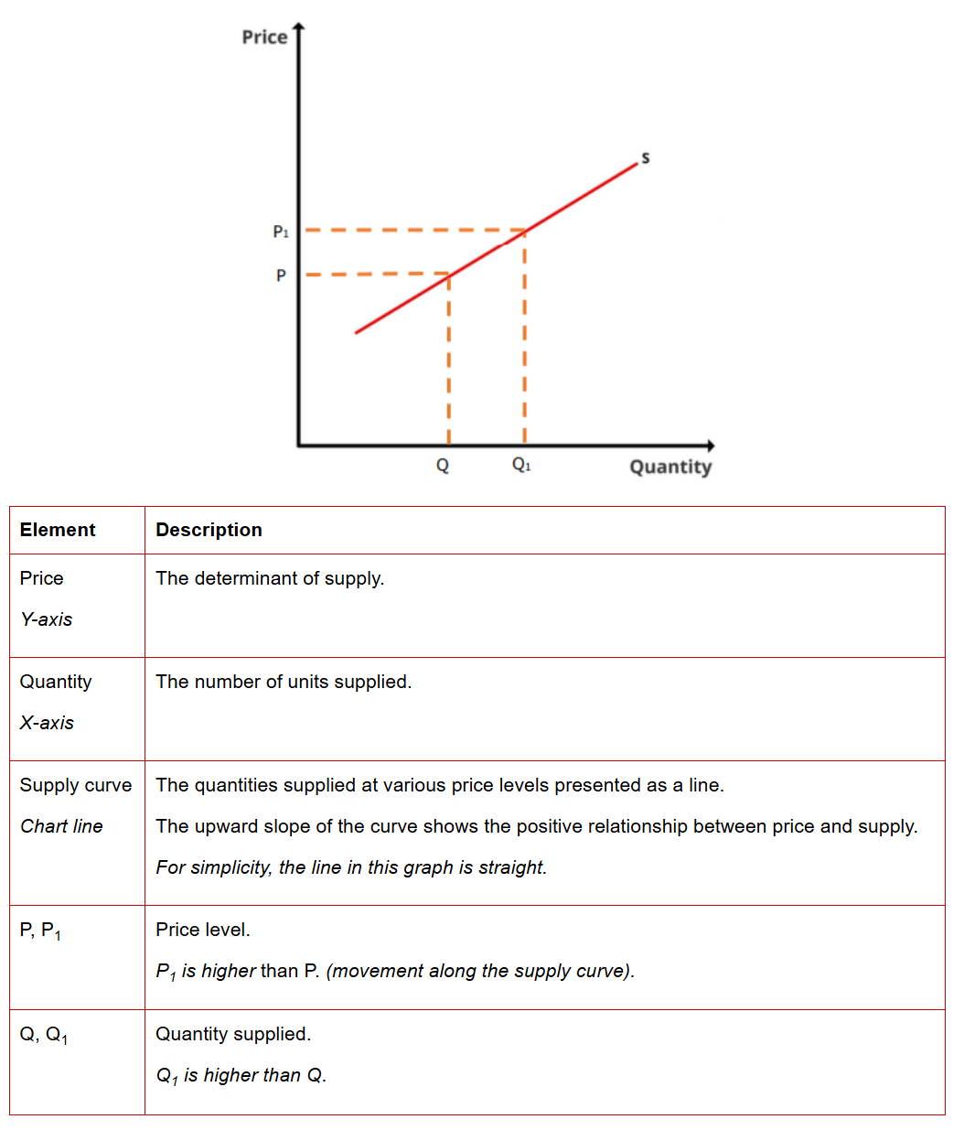

**Belongs_to:** Supply

**Includes:** Movement along supply curve, Shift in supply curve

**Related_to:** Demand curve

**Entity: Movement along supply curve**

**Definition:**

**Interpretation:** Higher prices lead to higher supply (expansion). Lower prices lead to lower supply (contraction). This is shown as movement along the supply curve.

**Formula:**

**Example:**

The supply at various price levels can be shown on a graph:

When price is P, quantity is Q, when price is P1, quantity is Q1. This shows a movement along the supply curve.



**Belongs_to:** Supply curve

**Related_to:** Shift in supply curve

**Entity: Shift in supply curve**

**Definition:** The determinants of supply shift the entire supply curve left or right, meaning that supply changes despite prices remaining unchanged.

**Interpretation:** A change in supply can occur as a result of new technologies, such as more efficient or less expensive production processes, or a change in the number of competitors in the market.

**Formula:**

**Example:** Apple would like to supply more iPhone to the market thanks to the cost of raw material has declined.

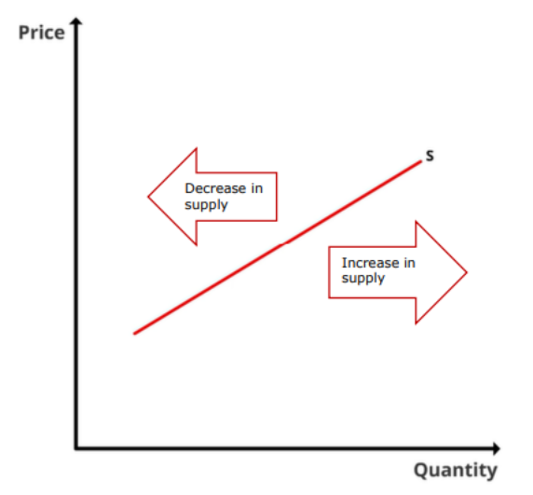

**Belongs_to:** Supply curve

**Includes:** Input prices, Advanced technology, Prices of substitutes, Producer expectations, Number of sellers

**Related_to:** Movement along supply curve

**Entity: Input prices**

**Definition:** Prices of inputs, including machinery, rent, materials, labour, etc., affect supply.

**Interpretation:** Higher input prices decrease supply. Lower input prices increase supply. This includes the effects of government intervention (taxes, subsidies, etc.) on inputs.

**Formula:**

**Example:** Strengthing exchange rates allow C Co’s to buy imported materials at lower prices and increase production illustrates input prices.

**Belongs_to:** Shift in supply curve

**Related_to:** Advanced technology, Prices of substitutes, Producer expectations, Number of sellers

**Entity: Advanced technology**

**Definition:** New innovation that has yet to reach many industries or tech that has been established but only used by highly trained specialists.

**Interpretation:** Improvements in technology enable producers to make more supply with lower marginal cost.

**Formula:**

**Example:** The installation of an automated production process significantly reduced the cost per unit of R Co’s products and increased its production speed illustrates advanced technology.

**Belongs_to:** Shift in supply curve

**Related_to:** Input prices, Prices of substitutes, Producer expectations, Number of sellers

**Entity: Prices of substitutes**

**Definition:** A production substitute is an alternative good the producer can supply.

**Interpretation:** Prices of production substitutes affect supply. Higher prices of production substitutes reduce supply, as more producers make the substitute. Lower prices of production substitutes increase supply as producers shift away from making substitutes.

**Formula:**

**Example:** SUVs enjoy higher selling prices than sedans, so BRD Co has shifted production to making more SUVs illustrates prices of substitutes.

**Belongs_to:** Shift in supply curve

**Related_to:** Input prices, Advanced technology, Producer expectations, Number of sellers

**Entity: Producer expectations**

**Definition:** The producer’s expectation of future prices will affect the current supply.

**Interpretation:** The reaction to expectations of higher prices varies. Some firms will increase capacity to produce more supply when prices rise. Other firms may stockpile or withhold current supply to take advantage of higher future prices.

**Formula:**

**Example:** The demand and price of rubber gloves are expected to increase, so QWER Co has invested in additional production facilities illustrates producer expectations.

**Belongs_to:** Shift in supply curve

**Related_to:** Input prices, Advanced technology, Prices of substitutes, Number of sellers

**Entity: Number of sellers**

**Definition:** How many sellers would like to offer supply to the market.

**Interpretation:** The greater the number of sellers, the greater the supply.

**Formula:**

**Example:** There are many producers of electronic components in City Z, making it the place to go for low-cost quantities of these parts illustrates number of sellers.

**Belongs_to:** Shift in supply curve

**Related_to:** Input prices, Advanced technology, Prices of substitutes, Producer expectations

**Entity: Equilibrium price**

**Definition:** The price level at which quantity supplied and demanded are equal.

**Interpretation:** The equilibrium price is where the supply of goods matches demand. When a major index experiences a period of consolidation or sideways momentum, it can be said that the forces of supply and demand are relatively equal and the market is in a state of equilibrium.

**Formula:**

**Example:**

In theory, the market price should be at the equilibrium price.

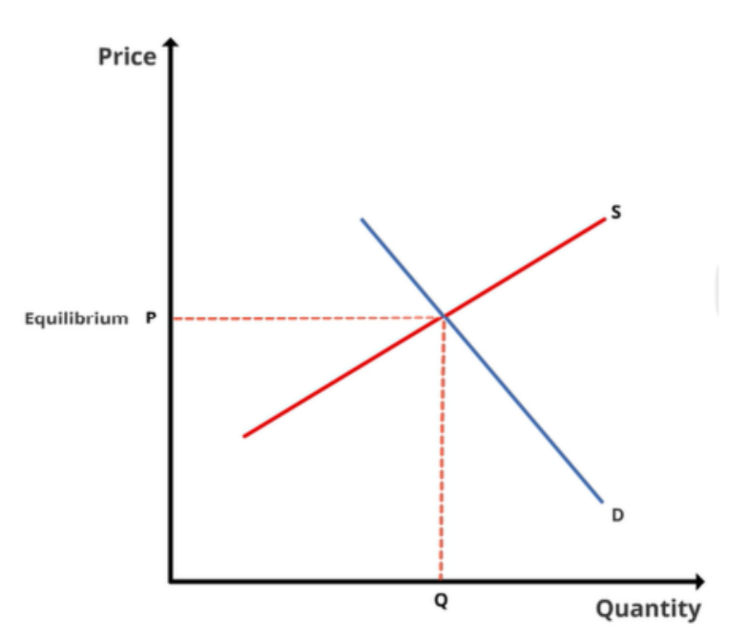

**Belongs_to:** Market

**Related_to:** **Equilibrium quantity**

**Entity: Equilibrium quantity**

**Definition:** The quantity at a specific price level where demand and supply are equal.

**Interpretation:** Supply and demand intersect, meaning the amount of an item that consumers want to buy is equal to the amount being supplied by its producers. In other words, the market has reached a perfect state of balance as prices stabilize to suit all parties.

**Formula:**

**Example:**

There may be a shift in the demand curve or the supply curve for a product. When this happens, the equilibrium price and quantity will change.

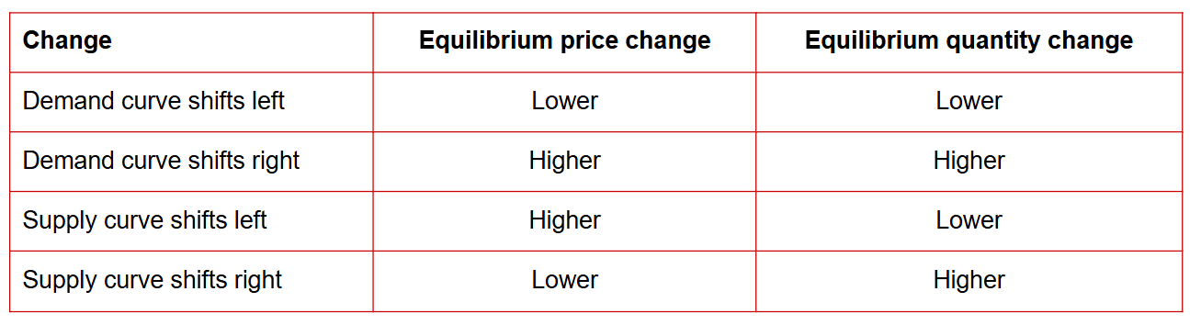

**Belongs_to:** Market

**Related_to: Equilibrium price**

**Entity: Elastic**

**Definition:** The rate of demand change is more than the rate of price change. Price elasticity of demand is greater than 1.

**Interpretation:** Companies that operate in fiercely competitive industries provide goods or services that are elastic because these companies tend to be price-takers or those that must accept prevailing prices. When the price of a good or service reaches the point of elasticity, sellers and buyers quickly adjust their demand for that good or service.

**Formula:**

**Example:** If one airline decides to increase the price of its fares, consumers can use another airline, and the airline that increased its fares will see a decrease in the demand for its services illustrates elastic.

**Belongs_to:** Demand

**Related_to:** Inelastic, Price elasticity of demand (PED), Income elasticity of demand, Cross elasticity of demand (XED)

**Entity: Inelastic**

**Definition:** The rate of demand change is less than the rate of price change. Price elasticity of demand is smaller than 1.

**Interpretation:** Inelastic demand means that when the price of a good or service goes up, consumers’ buying habits stay about the same, and when the price goes down, consumers’ buying habits also remain unchanged.

**Formula:**

**Example:** If the price increase had no impact whatsoever on the quantity demanded, the medication would be considered perfectly inelastic. Necessities and medical treatments tend to be relatively inelastic because they are needed for survival.

**Belongs_to:** Demand

**Related_to:** Elastic, Price elasticity of demand (PED), Income elasticity of demand, Cross elasticity of demand (XED)

**Entity: Price elasticity of demand (PED)**

**Definition:** The extent demand changes in response to changes in price.

**Interpretation:** A good is perfectly elastic if the price elasticity is infinite (if demand changes substantially even with minimal price change). If price elasticity is greater than 1, the good is elastic; if less than 1, it is inelastic. If a good’s price elasticity is 0 (no amount of price change produces a change in demand), it is perfectly inelastic.

**Formula:** Price elasticity of demand (PED)= Percentage change in quantity demanded/ percentage change in price

**Example:** The price of a good is $1.20 per unit and annual demand is 800,000. Market research indicates that an increase in price of 10 cents per unit will result in a fall in annual demand for the good of 70,000 units. Calculate the elasticity of demand at the current price of $1.20.

At a price of $1.20, annual demand is 800,000 units.

For a price rise:

Percentage change in demand= 70,000/800,000×100%=8.75%

Percentage change in price= 0.1/1.2×100%=8.33%

Price elasticity of demand = (-8.75%)/8.33%=-1.05

Ignoring the minus sign, the price elasticity at this point is 1.05. Demand is elastic at this point, because the elasticity is greater than 1.

**Belongs_to:** Demand

**Related_to:** Elastic, Inelastic, Income elasticity of demand, Cross elasticity of demand (XED)

**Entity: Income elasticity of demand**

**Definition:** Measures the responsiveness of demand to a change in income.

**Interpretation:** For inferior goods, the income elasticity of demand is negative. For necessity goods, the income elasticity of demand is between zero and one. For luxury goods, the income elasticity of demand is greater than one.

**Formula:** Income elasticity of demand (PED)= Percentage change in quantity demanded/ percentage change in income

**Example:** if household income increased by 5% and demand for mobile phones increased 8%, then the income elasticity of demand of mobile phones = 8%/5% = 1.6

**Belongs_to:** Demand

**Related_to:** Elastic, Inelastic, Price elasticity of demand (PED), Cross elasticity of demand (XED)

**Entity: Cross elasticity of demand (XED)**

**Definition:** The sensitivity of demand for one good to changes in the price of another good.

**Interpretation:** For Complements goods, the cross elasticity of demand is negative. For unrelated goods, the cross elasticity of demand is zero. For substitute goods, the cross elasticity of demand is positive.

**Formula:** Cross elasticity of demand (XED)= Percentage change in quantity demanded of goods A/ percentage change in the price of goods B

**Example:** Toothpaste is an example of a substitute good. The demand for a competitor's brand of toothpaste increases in turn if the price of one brand of toothpaste increases.

**Belongs_to:** Demand

**Related_to:** Elastic, Inelastic, Price elasticity of demand (PED), Income elasticity of demand

**Entity: Average cost (AC)**

**Definition:** The average economic cost of output per unit.

**Interpretation:**

**Formula:** Average cost = Total economic cost of output / Total output

**Example:**

The following information on the production of televisions is available:

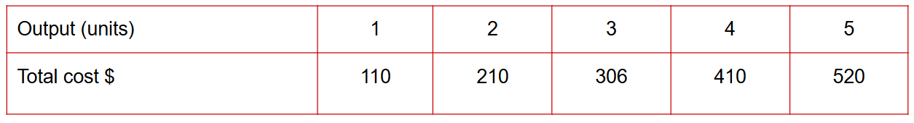

Calculate the average cost of televisions from the above data.

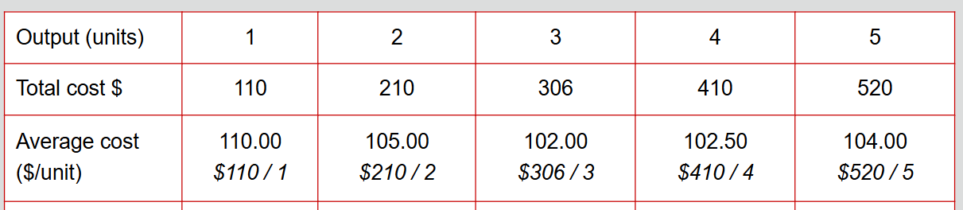

**Belongs_to:** Supply

**Related_to:** Marginal cost (MC), Law of diminishing returns, Marginal revenue (MR), Profit maximising rule

**Entity: Marginal cost (MC)**

**Definition:** The incremental economic cost of producing an additional output unit.

**Interpretation:**

**Formula:** MC = Total costn+1 – Total costn

n is the number of output units.

**Example:**

The following information on the production of televisions is available:



Calculate the marginal cost of televisions from the above data.

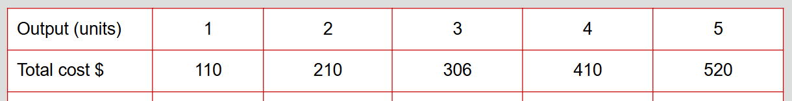

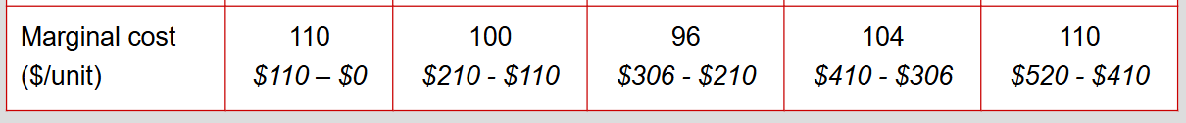

**Belongs_to:** Supply

**Related_to:** Average cost (AC), Law of diminishing returns, Marginal revenue (MR), Profit maximising rule

**Entity: Law of diminishing returns**

**Definition:** The law of diminishing returns says that, if you keep increasing one factor in the production of goods (such as your workforce) while keeping all other factors the same, you’ll reach a point beyond which additional increases will result in a progressive decline in output. In other words, there’s a point when adding more inputs will begin to hamper the production process.

**Interpretation:** In the short run, as output increases, the marginal cost (MC) will eventually increase (efficiency declines) at some point. This will eventually affect the average cost (AC). When MC < AC, AC reduces with additional output. When MC = AC,​ AC minimum. When MC > AC, AC increases with additional output.

**Formula:**

**Example:** Take a farmer with a limited number of acres. If that farmer has too few workers to farm the land, the farmer won’t be able to produce the maximum crop the land can yield. Adding more workers will likely increase the level of production- to a point. But if the farmer goes beyond this limit, production will begin to fall, simply because there are too many workers and not enough land.

**Belongs_to:** Supply

**Related_to:** Average cost (AC), Marginal cost (MC), Marginal revenue (MR), Profit maximising rule

**Entity: Marginal revenue (MR)**

**Definition:** The incremental revenue earned from selling an additional unit.

**Interpretation:** Analyzing marginal revenue helps a company identify the revenue generated from each additional unit sold. Marginal revenue is often shown graphically as a downward-sloping line representing how a company usually has to decrease its prices to drive additional sales.

**Formula:** MR = Total revenuen+1 – Total revenuen

n is the number of output units.

**Example:** 10 units sold at $9 each, resulting in total revenues of $90; 11 units sold at $8.50, resulting in total revenues of $93.50. This indicates the marginal revenue of the 11th unit is $3.50 ($93.50 - $90).

**Belongs_to:** Supply

**Related_to:** Average cost (AC), Marginal cost (MC), Law of diminishing returns, Profit maximising rule

**Entity:** **Profit maximising rule**

**Definition:** Profit is maximised when marginal cost equals marginal revenue. When MC = MR, profit maximised.

**Interpretation:** Profit is maximised when MC = MR. If MC < MR at the firm’s output level, the firm has some capacity to earn additional revenue by increasing production.

If MC > MR at the firm’s output level, each additional unit the firm makes is incurring a loss. The output should be reduced.

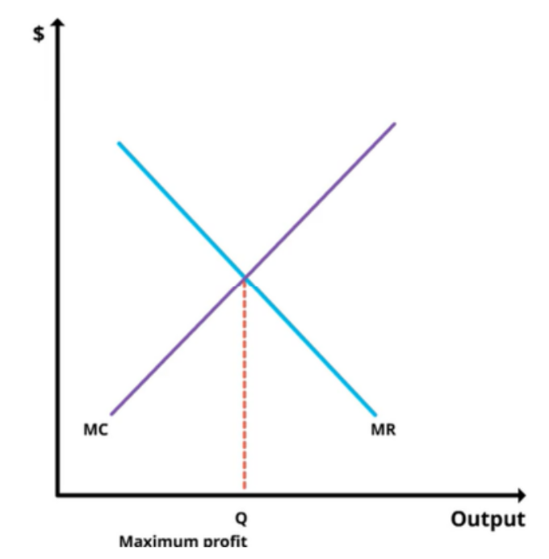

**Formula:**

**Example:** A company experiences the best results when production and sales continue until marginal revenue equals marginal cost. Beyond that point, the cost of producing an additional unit will exceed the revenue generated. If the company sells one additional unit for $100 but incurs a marginal cost of $105, the company will lose $5 in the process of selling that extra unit.

**Belongs_to:** Supply

**Related_to:** Average cost (AC), Marginal cost (MC), Law of diminishing returns, Marginal revenue (MR)

**Entity: Perfect competition**

**Definition:** A perfectly competitive market has many firms producing the same goods or services. The market is easy to enter and exit.

**Interpretation:** Producers attempting to sell at a higher price will not sell anything, and producers attempting to sell as a price below equilibrium would obtain 100% market share. There are few, if any, truly perfectly competitive markets in the real world.

**Formula:**

**Example:** There are many fruit sellers of similar size in the local market. All the fruit sellers in the market sell the same kind of banana. The market’s fruit sellers will all aim to sell their fruit at the market price. If they increase their prices above this level, their sales will drop drastically as consumers will buy from neighbouring stalls at the market instead. The market’s fruit sellers and buyers all have perfect knowledge about the product and prevailing prices. Any new fruit sellers can set up shop at the market, and any existing fruit sellers are free to leave.

**Belongs_to:** Market

**Related_to:** **Imperfect competition, Monopoly, Oligopoly, Monopolistic competition**

**Entity: Imperfect competition**

**Definition:** Imperfect competition is any market structure that does not satisfy the definition of perfect competition. Almost all markets are in some form of imperfect competition.

**Interpretation:** In an imperfectly competitive environment, companies sell different products and services, set their own individual prices, fight for market share, and are often protected by barriers to entry and exit, making it harder for new companies to challenge them.

**Formula:**

**Example:** Imperfect competition includes **monopoly, oligopoly and monopolistic competition.**

**Belongs_to:** Market

**Related_to:** **Perfect competition, Monopoly, Oligopoly, Monopolistic competition**

**Entity: Monopoly**

**Definition:** A market structure for which there is a dominant single seller.

**Interpretation:** A vital characteristic of a monopoly is that consumers have no substitutes for the good or service; they must buy from the monopolist. This allows a monopolist to be a price-maker, meaning it can set what price it wants (demand would be inelastic). To sustain a monopoly market structure, significant barriers to entry must prevent additional supplies from entering. These include: significant economies of scale, patents, government licenses, control of assets, geography or other natural barriers.

**Formula:**

**Example:** Among the most notable U.S. monopolies in history are Andrew Carnegie’s Steel Company (now U.S. Steel), John D. Rockefeller’s Standard Oil Company, and the American Tobacco Company. American monopolies date back to colonial administrators who awarded large companies exclusive contracts to help build the New World. From the late 19th to the early 20th century, these companies maintained singular control over the supply of their respective commodities. Without free-market competition, they could keep the prices of steel, oil, and tobacco high.

**Belongs_to:** Market

**Related_to:** **Perfect competition, Imperfect competition, Oligopoly, Monopolistic competition**

**Entity: Oligopoly**

**Definition:** A market structure where there are a few dominant sellers. Collusion and interdependence may exist.

**Interpretation:** Oligopoly has the following features: market influence, barriers to entry, keep an eye on rival firms and some product differentiation.

**Formula:**

**Example:** Because there are only three airlines for the route, they influence how many flights to run and how expensive the ticket fares should be. The three airlines would block or resist allowing other airlines to arrange flights on the same route. If one of the three airlines starts offering discount tickets, this may affect the business practices of the other two- for example, they may also begin offering discount tickets. One of the three airlines might claim that it offers the best food or most comfortable seats on its flights to differentiate from its rivals.

**Belongs_to:** Market

**Related_to:** **Perfect competition, Imperfect competition, Monopoly, Monopolistic competition**

**Entity: Monopolistic competition**

**Definition:** A market structure with a large number of firms competing with each other to become monopolies.

**Interpretation:** Monopolistic competition exists in a market where there are a large number of firms competing against each other. The firms try to make themselves more like monopolies by differentiating their products from their competitors.

**Formula:**

**Example:** Many sandwich shops on the high street compete for customers. One sandwich shop may claim to provide higher quality sandwiches than the other because it uses better quality ingredients or offers more variety or creative combinations of fillings. Different sandwich shops will use a variety of marketing and advertising mediums to promote themselves. A new sandwich shop on the high street should be able to find customers reasonably easily. Customers will often be willing to pay more for better quality food.

**Belongs_to:** Market

**Related_to:** **Perfect competition, Imperfect competition, Monopoly, Oligopoly**